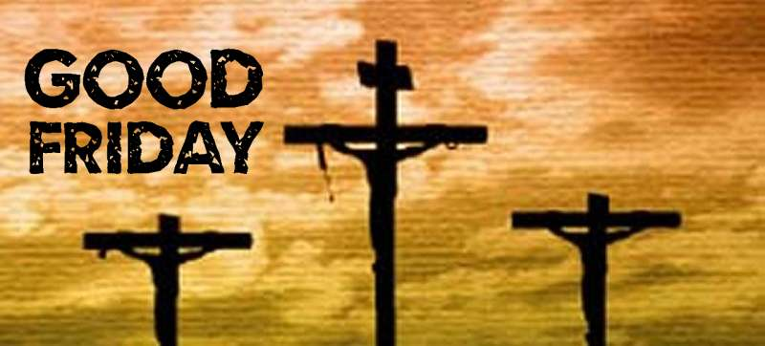

**Good Friday is the day on which Jesus Christ, having been betrayed by Judas and sentenced to death by Pontius Pilate, was crucified for the sins of mankind.**

**From the earliest days of Christianity, no Mass has been celebrated on Good Friday, since the Mass is a celebration both of the sacrifice of Christ on the Cross and of His Resurrection**